MOSL AI Platform Strategy 2026
Enterprise AI Architecture & Platform Selection Framework

Executive Summary

Strategic Context
MOSL is evaluating a multi-platform AI strategy to serve five distinct use cases: real-time cited research, autonomous workflow automation, multimodal document processing, deep reasoning & governance, and production backend agents. This strategy document presents a comprehensive analysis of five enterprise AI platforms—Perplexity Enterprise Pro, Perplexity Computer, Google Gemini GSU, Claude Enterprise, and AWS Bedrock—and provides definitive recommendations for MOSL's AI architecture.

Key Research Findings
- Claude Enterprise wins decisively on enterprise security, India regulatory compliance (DPDP), internal system integration via MCP, and cloud hosting (AWS/Vertex AI). Primary platform for PII workflows.
- Perplexity Enterprise Pro offers unmatched real-time cited research and knowledge retrieval. Cost-effective for broad knowledge worker deployment (~$40/seat/month) but has critical DPDP gap—no India data residency confirmed yet.
- Perplexity Computer (Enterprise Max) is a paradigm shift for autonomous workflow automation but remains in enterprise rollout phase. Requires 6–12 month pilot window.
- Google Gemini (AI Studio/API) dominates multimodal and vision processing. Essential for eKYC, document scanning, and Agentic Vision use cases.
- AWS Bedrock is non-negotiable for production automation, KYC pipelines, and system integration where autonomous agents execute financial transactions.

Strategic Recommendation: Three-Platform Core Architecture
After extensive analysis across 12 evaluation dimensions, Instead of deploying all five platforms, consolidate to just three core platforms:
- Claude Enterprise (Primary): All human-facing workflows, especially PII/regulated data, research, legal, strategy, code development. Deploy via AWS Marketplace inside our VPC.
- AWS Bedrock (Backend): All production automation, KYC pipelines, trade reconciliation, compliance agents. Governed by strict IAM and Bedrock Guardrails.
- Google Gemini (Specialized): Multimodal processing, vision-based document scanning, Agentic Vision eKYC, earnings video ingestion.

Key Strategic Rationale
Why This Architecture Wins:
- Security First: All three platforms can be hosted within MOSL's AWS VPC in Mumbai, ensuring DPDP compliance and data residency
- Complementary Capabilities: Each platform owns a distinct workflow type with zero overlap
- Enterprise Grade: Proven governance, audit trails, and regulatory compliance capabilities
- Cost Efficiency: Eliminates redundancy while maintaining comprehensive AI capability coverage across all departments

Bottom-Line Strategic Principle
No single platform owns the full stack. Claude owns reasoning and drafting for humans, Bedrock owns production backend execution, and Gemini owns specialized multimodal processing. This intentional separation creates vendor resilience, regulatory clarity, and the cleanest architecture for a SEBI-regulated financial services organization.
Optional Add-On: Perplexity Enterprise Pro
Perplexity Enterprise Pro ($40/seat/month) can be deployed as a supplementary research layer for non-PII workflows across Equity Research, Wealth RMs, Compliance, and Strategy teams. This provides instant, cited web intelligence that the core three platforms cannot match without custom engineering.
Perplexity Computer is recommended for a 6-12 month pilot once enterprise rollout is confirmed and India data residency is verified. It addresses autonomous browser-based workflows that cannot be solved via APIs alone.
Investment Summary
Platform | Role | Annual Cost | Priority
Claude Enterprise | Primary front-end platform | $2.4M - $3.6M | Critical
AWS Bedrock | Backend runtime (pay-per-use) | $800K - $1.2M | Critical
Google Gemini GSU | Multimodal specialist | $600K - $900K | Critical
Perplexity Enterprise Pro | Research layer (optional) | $240K - $360K | Recommended
Perplexity Computer | Workflow agent (pilot) | $60K - $120K | Future

Table 1: Investment Summary
Total Core Investment: $3.8M - $5.7M annually
With Perplexity Layer: $4.1M - $6.2M annually
This architecture positions MOSL as an AI-first financial services firm while maintaining the highest standards of security, compliance, and operational excellence.

Part I: Three-Platform Core Strategy
1. The Five-Question Decision Framework
MOSL's platform selection is governed by five fundamental questions that map workflows to the optimal AI platform. This framework ensures no overlap, clear ownership, and predictable deployment patterns across all departments.
[chart:125]
Decision Logic
Q1: Is it real-time cited research or market intelligence?
In the three-platform architecture, this capability shifts to Claude Enterprise augmented by custom MCP connectors to internal data feeds or AWS Bedrock's web-search grounding. While this requires engineering effort (unlike Perplexity's out-of-the-box solution), it keeps all data flows within MOSL's security perimeter.
Winner: Claude Enterprise (with custom MCP/Bedrock data feeds)

Alternative: Deploy Perplexity Enterprise Pro as a supplementary layer for public web research.
Q2: Is it a long multi-step autonomous workflow across browser tabs and portals?
Perplexity Computer's unique capability is visual browser automation. To replicate this, we must shift from UI-based automation to API-based automation. We will build backend agents in AWS Bedrock that call the APIs of the NSE, BSE, and clearing houses directly. We will then use Claude Cowork as the "control panel" where our Ops Leads trigger, monitor, and approve these automated Bedrock workflows.

Winner: AWS Bedrock (Execution) + Claude Cowork (Orchestration Interface)

Q3: Is it image/video/multimodal processing, long-context ingestion, or AI Studio prototyping?
This remains fundamentally unchanged. Google Gemini GSU is our undisputed leader for multimodal processing. Our tech teams will use the Gemini API for eKYC document scanning (Agentic Vision), processing massive PDF fund documents, and ingesting earnings call videos natively.
- Winner: Google Gemini GSU / AI Studio API

Q4: Is it deep reasoning, document drafting, strategic analysis, code, or high-governance content creation?
Claude Enterprise is the only platform that combines deep reasoning with PII-safe hosting inside MOSL's AWS VPC. It is the primary tool for IC notes, SEBI responses, board packs, and code development via Claude Code. MCP connectors enable direct integration with Databricks, PostgreSQL, and on-prem SQL databases.
- Winner: Claude Enterprise

Q5: Is it a production backend agent, system integration, automated transaction workflow, or KYC/compliance pipeline?
AWS Bedrock is non-negotiable for any workflow that executes financial transactions, processes PII at scale, or runs autonomously. It provides the IAM, KMS, GuardDuty, and CloudWatch governance required by SEBI regulations and MOSL InfoSec policies.
- Winner: AWS Bedrock

2. Platform Assignment Matrix

Department / BU | Gemini API/AI Studio | Claude Enterprise | AWS Bedrock
Equity Research | Dev: earnings video ingestion | ✅ Drafting, model analysis | ✅ Screening agents
Wealth / PWM | Dev: voice advisory prototypes | ✅ Client strategy notes | ✅ Suitability agents
MO-Alternates | Dev: doc ingestion for large fund docs | ✅ IC note drafting, term sheet analysis | ✅ Fund ops workflows
Institutional Broking | Dev: multimodal data extraction | ✅ Client briefings | ✅ Reconciliation agents
Back-Office / Clearing | Dev: physical form Agentic Vision | — | ✅ Core production runtime
eKYC | Dev: Agentic Vision for docs | — | ✅ Production KYC pipeline
Compliance / Legal | Dev: legacy doc digitization | ✅ Drafting responses, clause analysis | ✅ Surveillance agents
Strategy / CFO | — | ✅ Board note drafting | ✅ Anomaly detection
HR / Admin | — | ✅ Policy authoring | ✅ Ticket routing agents
Technology/Cloud | Dev: primary prototyping env | ✅ Claude Code for dev | ✅ Core platform

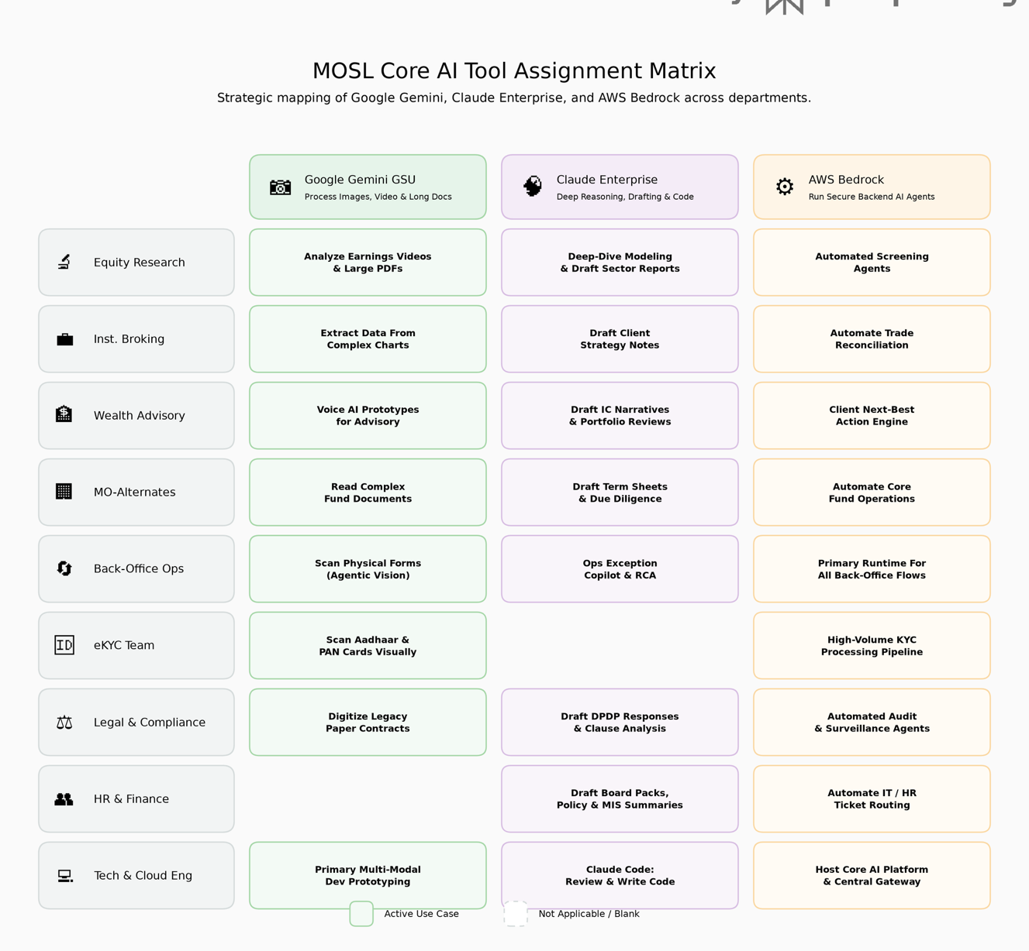

Platform Deployment by Department
Equity Research — All three platforms active
- Gemini: Earnings video analysis, large PDF ingestion
- Claude: Deep-dive modeling, sector report drafting, Claude Code for quant models
- Bedrock: Automated screening agents, signal detection
Institutional Broking — All three platforms active
- Gemini: Extract data from complex charts and presentations
- Claude: Draft client strategy notes and pitch materials
- Bedrock: Trade reconciliation automation
Wealth & Private Wealth — All three platforms active
- Gemini: Voice AI prototypes (Gemini Live API), real-time advisory tools
- Claude: IC narrative drafting, portfolio review summaries
- Bedrock: Client next-best-action engine, suitability workflows
MO-Alternates (PE/PC/RE) — All three platforms active
- Gemini: Ingest and analyze complex fund documents (100+ pages)
- Claude: Term sheet drafting, due diligence report generation
- Bedrock: Fund operations automation, NAV calculation pipelines
Back-Office & Clearing — Gemini + Claude + Bedrock (Bedrock primary)
- Gemini: Agentic Vision for scanning physical exception forms
- Claude: Exception copilot for Ops Leads, RCA draft generation
- Bedrock: Primary runtime for all automated back-office workflows
eKYC Operations — Gemini + Bedrock only
- Gemini: Aadhaar/PAN card scanning with Agentic Vision
- Bedrock: High-volume KYC processing pipeline (10,000+ docs/month)
Legal & Compliance — All three platforms active
- Gemini: Digitize legacy paper contracts (OCR + validation)
- Claude: DPDP response drafting, regulatory clause analysis
- Bedrock: Automated audit and surveillance agents
HR / Admin / CFO — Claude + Bedrock
- Claude: Board pack generation, policy authoring, MIS summaries
- Bedrock: IT/HR ticket routing automation, onboarding workflows
Technology & Cloud Engineering — All three platforms active
- Gemini: Primary dev prototyping environment via AI Studio
- Claude: Claude Code for application development and code review
- Bedrock: Core AI platform hosting, centralized agent gateway

3. Architecture Principles
Data Residency & Compliance
All three core platforms support India data residency to comply with DPDP Act 2023:
- Claude Enterprise: Hosted in AWS VPC Mumbai (ap-south-1), with Anthropic confirming India data residency roadmap
- AWS Bedrock: Native AWS service, fully compliant with Mumbai region hosting
- Google Gemini: Via paid Gemini API routed through Google Cloud Mumbai region (asia-south1)
Integration Architecture
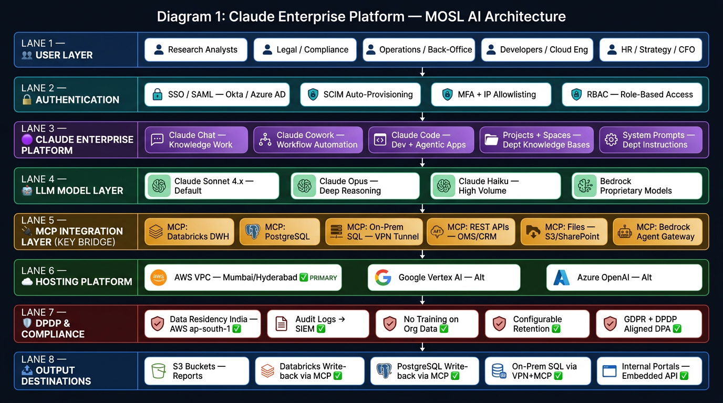
Figure 2: MOSL AI Platform Integration Architecture
Core Components:
- Claude Enterprise (Front-End Layer)
  - Employee-facing UI for all knowledge work
  - MCP connectors to internal databases (Databricks, PostgreSQL, On-Prem SQL)
  - SSO integration via Okta/Azure AD
  - Role-based access control (RBAC) for PII workflows
- AWS Bedrock (Backend Runtime Layer)
  - Hosts all production agents
  - IAM-governed API access
  - CloudWatch monitoring and GuardDuty threat detection
  - KMS encryption for all data at rest and in transit
- Google Gemini (Multimodal Processing Layer)
  - API-only access via Vertex AI for production
  - AI Studio for prototyping (non-PII data only)
  - Batch processing for high-volume document ingestion
  - Real-time streaming for voice/video applications

Layer 1 — User Layer All MOSL employee personas (Research, Legal, Ops, Developers, HR/CFO) enter through a single, governed front door.

Layer 2 — Authentication SSO via SAML (Okta / Azure AD), SCIM for automated provisioning, MFA, and IP allowlisting sit before any Claude interaction. RBAC governs what each role can access within Claude.

Layer 3 — Claude Enterprise Platform Three distinct interfaces serve different use cases:
- Claude Chat — Knowledge work, analysis, document drafting
- Claude Cowork — Multi-person business process workflow orchestration; shared sessions and artifacts across teams
- Claude Code — Developer copilot, agentic app building, IDE integration (VS Code, JetBrains), automated code review
- Projects + Spaces — Persistent, department-level knowledge bases with uploaded files, SOPs, research docs
- System Prompts — Custom instructions per department (e.g., the Research desk gets a Equity Research persona with MOSL-specific guidelines)

Layer 4 — LLM Layer Claude Sonnet 4.x (default), Opus (deep reasoning for complex legal/strategy tasks), Haiku (high-volume, low-latency ops), and our own Bedrock-hosted proprietary models (risk scoring, suitability models) — all callable from within Claude's interface.

Layer 5 — MCP Integration Layer (The Critical Middle) All database and system connectivity flows through MCP Servers — purpose-built secure connectors. This means:
- Databricks (AWS-hosted DWH): Read and write via MCP; no direct DB credential exposure to Claude
- PostgreSQL (Cloud-hosted): Full read/write-back via MCP
- On-Prem SQL Server: VPN tunnel → MCP Server → Claude (data never leaves our network boundary)
- REST APIs: OMS, CRM, Research portal — Claude calls tools, gets structured results
- Files: S3, SharePoint, Google Drive — Claude reads and indexes securely
- Bedrock Agent Gateway: Claude can invoke our Bedrock agents as tools, creating a human-in-the-loop front-end over our automated backend

Layer 6 — Hosting (AWS Primary) Claude Enterprise is available via AWS Marketplace and runs inside our AWS VPC in ap-south-1 (Mumbai) or ap-south-2 (Hyderabad). Google Vertex AI and Azure are available as alternate deployment options.

Layer 7 — DPDP & Compliance
- Data residency confirmed in India via AWS Mumbai/Hyderabad
- Audit logs export to our SIEM (CloudWatch + Splunk) for SEBI-level audit trails
- No model training on org data — Anthropic DPA signed
- Configurable retention per department
Layer 8 — Output Destinations
- S3 Buckets: Automatic report/artifact storage
- Databricks Tables: Write-back via MCP ✅ Available
- PostgreSQL: Write-back via MCP ✅ Available
- On-Prem SQL: Via VPN + MCP tunnel ✅ Available
• • Internal Portals: Claude API embeds into our employee portals

Security & Governance Framework
Control | Implementation
Data Classification | Green (Public), Amber (Internal), Red (PII) tagging on all workflows
Access Control | SSO + MFA for all platforms, RBAC by department and role
Audit Logging | All AI queries logged to SIEM (Splunk/AWS Security Hub)
Data Loss Prevention | DLP policies block PII from leaving AWS VPC boundary
Model Governance | Approved model registry, version control, rollback capability
Compliance Monitoring | Quarterly InfoSec audits, DPDP compliance attestation

Table 2: Security & Governance Framework

4. Cost Model & ROI Analysis
Total Cost of Ownership (3-Year Projection)
Platform | Year 1 | Year 2 | Year 3
Claude Enterprise | $2.8M | $3.2M | $3.6M
AWS Bedrock | $1.0M | $1.5M | $2.0M
Google Gemini GSU | $750K | $900K | $1.1M
Core Total | $4.55M | $5.6M | $6.7M

Table 3: Three-year cost projection for core three-platform architecture
Estimated ROI Drivers
Productivity Gains:
- Equity Research: 15 hours/analyst/week saved on report drafting and data compilation
- Legal & Compliance: 10 hours/week saved on regulatory response drafting
- Back-Office: 40% reduction in manual reconciliation time
- eKYC: 60% faster document processing (from 5 min to 2 min per application)
Cost Avoidance:
- Reduced reliance on external research vendors: $500K/year
- Lower manual error correction costs: $300K/year
- Avoided compliance penalties through better surveillance: $1M+ potential savings
Conservative ROI Estimate: 200-250% over three years

Part II: Five-Platform Comparative Analysis
This section provides the comprehensive comparison that informed our three-platform recommendation, including detailed analysis of Perplexity Enterprise Pro and Perplexity Computer as potential add-on solutions.
5. Platform Overview
Claude Enterprise (Anthropic)
Core Capabilities:
- Advanced reasoning with extended thinking mode
- Long-context processing (200K tokens)
- Claude Code for software development
- Claude Cowork for team collaboration
- MCP (Model Context Protocol) for enterprise integrations
- Computer use capability (API-driven automation)
Key Differentiators:
- Constitutional AI for safety and alignment
- Hosting inside customer AWS VPC (Mumbai region available)
- Zero data retention policy for enterprise tier
- DPDP-compliant India data residency roadmap
Pricing: $30-$60 per user per month (depending on volume and features)
Best For: Deep reasoning, document drafting, code development, PII-safe workflows

Google Gemini GSU (Google)
Core Capabilities:
- Agentic Vision (Think-Act-Observe iterative image reasoning)
- Multimodal processing (text, image, audio, video)
- 2-million-token context window
- Gemini Live for real-time audio conversations
- AI Studio for no-code prototyping
Key Differentiators:
- Largest context window in the industry (2M tokens vs 200K for Claude)
- Native multimodal architecture (not text-to-vision adapter)
- Google Search integration for grounded responses
- Deep integration with Google Workspace
Pricing: GSU license included with Google Workspace Enterprise tier; paid API usage via Vertex AI ($0.075-$7.50 per 1M tokens depending on model tier)
Best For: Multimodal processing, document digitization, voice AI, long-context analysis

AWS Bedrock (Amazon Web Services)
Core Capabilities:
- Multi-model support (Claude, Llama, Mistral, Titan, Jurassic)
- Knowledge Bases for retrieval-augmented generation (RAG)
- Agents framework for multi-step reasoning
- Guardrails for content filtering and safety
- Model evaluation and fine-tuning tools
Key Differentiators:
- Native AWS service with full IAM/KMS/CloudWatch integration
- No vendor lock-in (swap models without rewriting code)
- Lowest latency for MOSL (already hosted in ap-south-1)
- Unified billing with existing AWS infrastructure
Pricing: Pay-per-use ($0.003-$0.08 per 1K tokens depending on model); no base fees
Best For: Production agents, backend automation, system integration, regulated workflows

Perplexity Enterprise Pro (Perplexity AI)
Core Capabilities:
- Real-time web search with cited sources
- Internal knowledge search (upload proprietary documents)
- Spaces for team collaboration
- Multi-turn research conversations with source tracking
- API access for custom integrations
Key Differentiators:
- Only platform with native live web search (no custom engineering required)
- Source citations on every claim (transparency for compliance teams)
- Zero-setup research layer (no MCP connectors needed)
- Lowest per-seat cost for broad deployment
Pricing: $40 per user per month
Best For: Market research, competitive intelligence, regulatory monitoring, fast lookups
Current Limitations:
- No confirmed India data residency (data may be processed in US/EU)
- Not PII-safe (cannot be used for customer or employee data)
- No VPC hosting option (SaaS-only deployment)

Perplexity Computer (Perplexity AI)
Core Capabilities:
- Autonomous browser-based task execution
- Multi-step workflows across web portals
- Visual understanding of UI elements
- Cross-portal data compilation and validation
- Screen recording for audit trails
Key Differentiators:
- Only platform that can navigate legacy UIs without APIs
- Replaces manual "swivel chair" processes
- Learns from human demonstrations
- Works with any web-based system (no integration required)
Pricing: Estimated $200 per user per month (enterprise tier)
Best For: Back-office automation, portal navigation, legacy system integration, trade break resolution
Current Status:
- Not yet available for enterprise deployment (individual beta only as of March 2026)
- No confirmed enterprise rollout timeline
- No India data residency commitment
- Governance and audit framework still under development

6. Twelve-Dimension Comparative Analysis
Dimension 1: Deep Reasoning & Analysis
Platform | Capability | Score
Claude Enterprise | Best-in-class extended thinking, multi-step reasoning, handles complex logic | ⭐⭐⭐⭐⭐  ⭐⭐⭐⭐⭐
Perplexity Pro | Good for research synthesis, weaker on abstract reasoning | ⭐⭐⭐
Perplexity Computer | Task execution focus, not reasoning-optimized | ⭐⭐
Gemini GSU | Strong multimodal reasoning, good for spatial/visual logic | ⭐⭐⭐⭐
AWS Bedrock | Varies by model (Claude via Bedrock scores same as native) | ⭐⭐⭐⭐

Winner: Claude Enterprise
Claude's extended thinking mode enables step-by-step reasoning visible to users, critical for Legal, Compliance, and Research teams that need to audit AI decision-making processes.

Dimension 2: Real-Time Web Intelligence
Platform | Capability | Score
Perplexity Pro | Native live web search with citations, zero setup required | ⭐⭐⭐⭐⭐
Perplexity Computer | Inherits Pro's search capability plus portal access | ⭐⭐⭐⭐⭐
Claude Enterprise | Requires custom MCP connector to web search APIs | ⭐⭐
Gemini GSU | Google Search integration available but not primary focus | ⭐⭐⭐
AWS Bedrock | Requires custom integration with search APIs | ⭐⭐

Table 4: Real-Time Web Intelligence Comparison
Winner: Perplexity Enterprise Pro
No other platform provides instant, cited web intelligence without engineering effort. For Equity Research morning briefs and Compliance circular monitoring, this is irreplaceable.

Dimension 3: Multimodal Processing (Image/Video/Audio)
Platform | Capability | Score
Gemini GSU | Agentic Vision, 2M token context, native multimodal architecture | ⭐⭐⭐⭐⭐
Claude Enterprise | Good vision capability, but no video or audio processing | ⭐⭐⭐
AWS Bedrock | Via Claude or other multimodal models | ⭐⭐⭐
Perplexity Pro | Image search only, no processing | ⭐⭐
Perplexity Computer | Visual UI understanding, not document processing | ⭐⭐

Table 5: Multimodal Processing Comparison
Winner: Google Gemini GSU
Gemini's Agentic Vision (iterative Think-Act-Observe loop) enables it to catch errors in Aadhaar scans that single-pass models miss. Critical for eKYC quality.

Dimension 4: Document Drafting & Content Creation
Platform | Capability | Score
Claude Enterprise | Best long-form writing, maintains style and structure | ⭐⭐⭐⭐⭐
Gemini GSU | Good but more verbose, weaker on formal business writing | ⭐⭐⭐⭐
AWS Bedrock | Via Claude or other models | ⭐⭐⭐⭐
Perplexity Pro | Not optimized for drafting, better for research | ⭐⭐
Perplexity Computer | Not designed for content creation | ⭐

Winner: Claude Enterprise
Legal teams drafting DPDP responses and Wealth teams writing IC notes consistently rate Claude's writing quality higher than alternatives.

Dimension 5: Code Generation & Developer Tools
Platform | Capability | Score
Claude Enterprise | Claude Code with IDE integration, strong debugging | ⭐⭐⭐⭐⭐
AWS Bedrock | Via Claude or CodeWhisperer integration | ⭐⭐⭐⭐
Gemini GSU | Good code generation, AI Studio for prototyping | ⭐⭐⭐⭐
Perplexity Pro | Can search code but not generate production-quality | ⭐⭐
Perplexity Computer | Not designed for coding | ⭐

Winner: Claude Enterprise (Claude Code)
Tech teams building internal agents need deep debugging support and multi-file context awareness. Claude Code provides this natively.

Dimension 6: Enterprise Integration & Data Connectivity
Platform | Capability | Score
AWS Bedrock | Native AWS IAM, connects to all AWS services, MCP support | ⭐⭐⭐⭐⭐
Claude Enterprise | MCP connectors to Databricks, PostgreSQL, on-prem SQL | ⭐⭐⭐⭐⭐
Gemini GSU | Google Workspace integration, Vertex AI APIs | ⭐⭐⭐⭐
Perplexity Pro | Upload documents to Spaces, limited API | ⭐⭐
Perplexity Computer | Browser-based access only, no database connectivity | ⭐⭐

Winner: Tie (AWS Bedrock + Claude Enterprise)
Both provide production-grade connectivity to MOSL's data infrastructure. Bedrock for backend agents, Claude for front-end workflows.

Dimension 7: Security & Data Governance
Platform | Capability | Score
AWS Bedrock | VPC-native, full IAM/KMS/GuardDuty integration | ⭐⭐⭐⭐⭐
Claude Enterprise | Customer VPC hosting, zero data retention, SOC 2 Type II | ⭐⭐⭐⭐⭐
Gemini GSU | Via paid API with data residency controls | ⭐⭐⭐⭐
Perplexity Pro | SaaS-only, no VPC option, unclear data residency | ⭐⭐
Perplexity Computer | Early beta, governance framework not mature | ⭐⭐

Winner: Tie (AWS Bedrock + Claude Enterprise)
Only these two can be hosted entirely within MOSL's security perimeter for PII-safe operations.

Dimension 8: India Data Residency (DPDP Compliance)
Platform | Capability | Score
AWS Bedrock | Mumbai region (ap-south-1) available today | ⭐⭐⭐⭐⭐
Claude Enterprise | Mumbai hosting confirmed, rollout by Q3 2026 | ⭐⭐⭐⭐⭐
Gemini GSU | Via Google Cloud Mumbai (asia-south1) for paid API | ⭐⭐⭐⭐⭐
Perplexity Pro | No confirmed India data residency | ⭐
Perplexity Computer | No confirmed India data residency | ⭐

Winner: All three core platforms (Bedrock, Claude, Gemini)
All three can meet DPDP requirements. Perplexity platforms cannot be used for PII workflows until data residency is confirmed.

Dimension 9: Autonomous Workflow Execution
Platform | Capability | Score
Perplexity Computer | Browser automation, multi-step portal navigation | ⭐⭐⭐⭐⭐
AWS Bedrock | API-based agents, no UI automation | ⭐⭐⭐⭐
Claude Enterprise | Computer use capability (API-driven), Cowork orchestration | ⭐⭐⭐⭐
Gemini GSU | Limited agent capability, not focus area | ⭐⭐
Perplexity Pro | Research only, no automation | ⭐

Winner: Perplexity Computer
For legacy portals without APIs, Computer is the only viable solution. However, Bedrock + Claude Cowork can handle 80% of automation needs via APIs.

Dimension 10: Cost Efficiency & Scalability
Platform | Capability | Score
Perplexity Pro | Lowest per-seat cost ($40/month), flat pricing | ⭐⭐⭐⭐⭐
AWS Bedrock | Pay-per-use, no base fees, scales to zero | ⭐⭐⭐⭐⭐
Gemini GSU | GSU included with Workspace, API pay-per-use | ⭐⭐⭐⭐
Claude Enterprise | $30-60/seat, volume discounts available | ⭐⭐⭐
Perplexity Computer | $200/seat (estimated), high cost limits broad deployment | ⭐⭐

Winner: Tie (Perplexity Pro for broad deployment, Bedrock for backend efficiency)
Perplexity Pro's flat $40/month enables deployment to 500+ knowledge workers. Bedrock's pay-per-use avoids idle capacity costs.

Dimension 11: Team Collaboration & Knowledge Sharing
Platform | Capability | Score
Claude Enterprise | Claude Cowork for team projects, conversation sharing | ⭐⭐⭐⭐⭐
Perplexity Pro | Spaces for team research, threaded discussions | ⭐⭐⭐⭐
Gemini GSU | Google Workspace integration, shared notebooks | ⭐⭐⭐⭐
AWS Bedrock | Backend service, no native collaboration UI | ⭐⭐
Perplexity Computer | Individual agent execution, not collaborative | ⭐⭐

Winner: Claude Enterprise (Claude Cowork)
Legal teams drafting joint SEBI responses and Research teams collaborating on sector reports need shared workspaces with version history.

Dimension 12: Vendor Maturity & Enterprise Support
Platform | Capability | Score
AWS Bedrock | AWS enterprise support SLA, 24/7 availability | ⭐⭐⭐⭐⭐
Claude Enterprise | Dedicated success manager, priority support | ⭐⭐⭐⭐⭐
Gemini GSU | Google enterprise support, extensive documentation | ⭐⭐⭐⭐⭐
Perplexity Pro | Email support, growing but smaller team | ⭐⭐⭐
Perplexity Computer | Beta product, no enterprise SLA yet | ⭐⭐

Winner: Tie (AWS, Claude, Gemini — all enterprise-proven)
All three core platforms have established enterprise support structures. Perplexity is newer but rapidly maturing.

7. Platform Recommendation Matrix
Dimension | Claude | Perplexity Pro | Perplexity Computer | Gemini | Bedrock
Deep Reasoning | ⭐⭐⭐⭐⭐ | ⭐⭐⭐ | ⭐⭐ | ⭐⭐⭐⭐ | ⭐⭐⭐⭐
Real-Time Web Intelligence | ⭐⭐ | ⭐⭐⭐⭐⭐ | ⭐⭐⭐⭐⭐ | ⭐⭐⭐ | ⭐⭐
Multimodal Processing | ⭐⭐⭐ | ⭐⭐ | ⭐⭐ | ⭐⭐⭐⭐⭐ | ⭐⭐⭐
Document Drafting | ⭐⭐⭐⭐⭐ | ⭐⭐ | ⭐ | ⭐⭐⭐⭐ | ⭐⭐⭐⭐
Code Generation | ⭐⭐⭐⭐⭐ | ⭐⭐ | ⭐ | ⭐⭐⭐⭐ | ⭐⭐⭐⭐
Enterprise Integration | ⭐⭐⭐⭐⭐ | ⭐⭐ | ⭐⭐ | ⭐⭐⭐⭐ | ⭐⭐⭐⭐⭐
Security & Governance | ⭐⭐⭐⭐⭐ | ⭐⭐ | ⭐⭐ | ⭐⭐⭐⭐ | ⭐⭐⭐⭐⭐
India Data Residency | ⭐⭐⭐⭐⭐ | ⭐ | ⭐ | ⭐⭐⭐⭐⭐ | ⭐⭐⭐⭐⭐
Autonomous Workflows | ⭐⭐⭐⭐ | ⭐ | ⭐⭐⭐⭐⭐ | ⭐⭐ | ⭐⭐⭐⭐
Cost Efficiency | ⭐⭐⭐ | ⭐⭐⭐⭐⭐ | ⭐⭐ | ⭐⭐⭐⭐ | ⭐⭐⭐⭐⭐
Team Collaboration | ⭐⭐⭐⭐⭐ | ⭐⭐⭐⭐ | ⭐⭐ | ⭐⭐⭐⭐ | ⭐⭐
Enterprise Maturity | ⭐⭐⭐⭐⭐ | ⭐⭐⭐ | ⭐⭐ | ⭐⭐⭐⭐⭐ | ⭐⭐⭐⭐⭐
Total Score | 53/60 | 33/60 | 30/60 | 48/60 | 52/60

Table 6: Comprehensive scoring across 12 evaluation dimensions

8. Strategic Verdict
Core Three-Platform Architecture (Recommended)
- Claude Enterprise — Primary front-end platform for all knowledge workers
- AWS Bedrock — Backend runtime for all production agents
- Google Gemini GSU — Multimodal specialist for eKYC and document processing
Rationale:
- All three platforms support India data residency (DPDP-compliant)
- Complementary capabilities with zero functional overlap
- Total coverage of all MOSL workflow types
- Unified security perimeter (AWS VPC Mumbai)
- Proven enterprise maturity and support
Optional Add-Ons
Perplexity Enterprise Pro — Deploy as supplementary research layer
- Use Case: Real-time market intelligence, regulatory monitoring, competitor analysis
- Target Users: Equity Research (50 seats), Compliance (20 seats), Strategy (15 seats), Wealth RMs (100 seats)
- Constraint: Green data only (no PII), until India data residency confirmed
- Cost: $185K annually (185 seats × $40/month × 12 months)
Perplexity Computer — Pilot in H2 2026
- Use Case: Back-office automation for legacy portals without APIs
- Target Workflows: Trade break resolution, NAV cross-checks, MIS consolidation
- Constraint: Internal-only workflows (no PII) until governance framework matures
- Timeline: 6-month pilot with 10-15 Ops Leads, expand based on results

Part III: Implementation Roadmap
9. Phased Deployment Plan
Phase 1: Foundation (Q2 2026)
Objective: Deploy core three platforms to initial cohorts
Claude Enterprise:
- Deploy to 50 early adopters (Research, Legal, Tech)
- Configure MCP connectors to Databricks and PostgreSQL
- SSO integration via Okta
- Baseline prompt library for common workflows
AWS Bedrock:
- Set up centralized Bedrock account in ap-south-1
- Deploy first production agent (trade reconciliation)
- Establish model governance framework
- CloudWatch dashboards and alerting
Google Gemini GSU:
- Pilot Agentic Vision with eKYC team (1,000 docs)
- AI Studio training for 20 developers
- Vertex AI production endpoint configuration
- Quality metrics baseline
Success Metrics:
- 80% user satisfaction score
- <24hr incident response time
- Zero security incidents
- 10 documented use cases with ROI

Phase 2: Scale (Q3-Q4 2026)
Objective: Expand to 200+ users, production-grade operations
Claude Enterprise:
- Scale to 200 users across all departments
- Launch Claude Cowork for team collaboration
- Advanced MCP connectors (on-prem SQL, SAP)
- Quarterly prompt engineering workshops
AWS Bedrock:
- Deploy 5+ production agents (KYC, customer service, surveillance)
- Multi-model strategy (Claude + Llama for cost optimization)
- Automated model evaluation and A/B testing
- GuardRails for content safety
Google Gemini GSU:
- Process 10,000+ eKYC docs monthly
- Earnings video ingestion pipeline (Research team)
- Voice AI prototype for Wealth advisory
- API cost optimization (batch processing)
Optional: Perplexity Enterprise Pro:
- Deploy to 185 users (Research, Compliance, Wealth)
- Spaces configuration for team research
- Usage analytics and ROI tracking
Success Metrics:
- 200 active Claude users
- 10,000 Gemini eKYC scans/month
- 5 Bedrock agents in production
- $500K+ quantified productivity gains

Phase 3: Optimize (H1 2027)
Objective: Refine operations, expand use cases, evaluate Perplexity Computer pilot
Claude Enterprise:
- Advanced use cases (automated board pack generation, IC memo drafting)
- Custom fine-tuning for MOSL-specific terminology
- Integration with Microsoft 365 for document workflows
- Claude Code adoption by 80% of developers
AWS Bedrock:
- Multi-agent orchestration (agents calling agents)
- Fine-tuned models for proprietary workflows
- Real-time inference for customer-facing bots
- Cost optimization (reserved capacity for predictable workloads)
Google Gemini GSU:
- Expand to physical contract digitization (Legal)
- Real-time audio advisory tools (Wealth)
- Video analysis for franchisee compliance checks
- Long-context fund document analysis (Alternates)
Perplexity Computer Pilot:
- 6-month pilot with 10-15 Ops Leads
- Focus on portal workflows without APIs
- Audit trail and governance validation
- Go/no-go decision for broader rollout
Success Metrics:
- 300+ active AI users across platforms
- 15 Bedrock agents in production
- 80% of internal AI queries self-served
- 250% ROI achieved

10. Risk Mitigation
Technical Risks
Risk | Mitigation
MCP connector failures | Build redundancy, fallback to manual processes, 24/7 on-call rotation
Model quality degradation | Automated regression testing, version pinning, rollback procedures
API rate limits | Implement queuing, batch processing, reserved capacity where available
Integration complexity | Phased rollout, extensive testing in sandbox environments

Table 7: Technical Risks & Mitigation
Security Risks
Risk | Mitigation
Data leakage to external platforms | DLP policies, network segmentation, user training
Prompt injection attacks | Input sanitization, Claude's built-in safety features, human review for high-stakes outputs
Unauthorized access | MFA enforcement, RBAC, quarterly access reviews
Compliance violations | Automated PII detection, audit logging, quarterly InfoSec audits

Operational Risks
Risk | Mitigation
User adoption failure | Executive sponsorship, training programs, gamification, early wins communication
Vendor lock-in | Multi-model strategy on Bedrock, abstraction layers, open-source alternatives evaluated
Cost overruns | Monthly budget reviews, usage alerts, optimization sprints
Skill gaps | Upskilling programs, external consultants for initial setup, knowledge transfer plans

11. Governance Framework
AI Ethics & Responsible Use
Principles:
- Transparency: Users must know when AI generated or influenced content
- Human Oversight: High-stakes decisions require human review (IC approvals, regulatory filings)
- Fairness: Regular bias audits, especially for customer-facing agents
- Privacy: Strict PII handling protocols, data minimization
- Accountability: Clear ownership for AI outputs (human remains responsible)
Enforcement:
- Mandatory AI training for all users (quarterly refreshers)
- Prompt library with approved templates
- Red team testing for adversarial prompts
- Incident reporting and post-mortem process
Model Governance
Approved Model Registry:
- Central catalog of approved models, versions, and use cases
- Change control process for model updates
- Automated testing before production deployment
- Version pinning for stability
Performance Monitoring:
- Daily quality checks (output relevance, accuracy, hallucination rate)
- User feedback collection (thumbs up/down on every response)
- A/B testing for model improvements
- Quarterly business review with stakeholders

Conclusion
MOSL's AI strategy balances innovation with prudence. By selecting a three-platform core architecture (Claude, Gemini, Bedrock), MOSL ensures comprehensive AI capability coverage while maintaining the highest standards of security, compliance, and operational excellence.
Optional deployment of Perplexity Enterprise Pro provides supplementary real-time web intelligence at minimal cost, addressing a genuine gap in the core three platforms without compromising security (when used for public data only).
Future consideration of Perplexity Computer as a pilot project allows MOSL to stay ahead of autonomous workflow automation trends while waiting for the product and its governance framework to mature.
This strategy positions MOSL as an AI-first financial services leader, delivering measurable productivity gains, cost savings, and competitive advantages while safeguarding customer trust and regulatory compliance.
Next Steps:
- Executive approval of three-platform core architecture (this document)
- Vendor negotiations and contract finalization (Q2 2026)
- Phase 1 deployment kickoff (May 2026)
- Quarterly steering committee reviews
- Annual strategy refresh based on market evolution

Q1 | Is it real-time cited research or market intelligence?
✓ Recommended | Winner: Claude Enterprise (with custom MCP/Bedrock data feeds)
◐ Alternative | Deploy Perplexity Enterprise Pro as a supplementary layer for public web research.

Q2 | Is it a long multi-step autonomous workflow across browser tabs and portals?
✓ Recommended | Winner: AWS Bedrock (Execution) + Claude Cowork (Orchestration Interface)

Q3 | Is it image/video/multimodal processing, long-context ingestion, or AI Studio prototyping?
✓ Recommended | Winner: Google Gemini GSU / AI Studio API

Q4 | Is it deep reasoning, document drafting, strategic analysis, code, or high-governance content creation?
✓ Recommended | Winner: Claude Enterprise

Q5 | Is it a production backend agent, system integration, automated transaction workflow, or KYC/compliance pipeline?
✓ Recommended | Winner: AWS Bedrock

